* 1. **Sequencing Technologies**
     1. **Genomes are Dynamics**

Genomes consist of multiple interacting parts and the way these operate together is highly complex. Genomes also evolve leading to differences within populations. These can be clinically relevant.

**The 4th Generation**

So I cheated when I described databases. The emphasis now is on tools and for genome-wide analyses there are a variety of complex tools with funny sounding names:

BEDTools

SAMTools

The Tuxedo Suite

Etc.

Brief introduction to Galaxy as a glue for these.

Link to Quickie videos.

**SCREENSHOT FROM GALAXY.**

Now, it’s time to learn about sequencing in more detail how do the various technologies work?

* + 1. **Sequencing Technologies**

In this section, we will explore sequencing technologies. The technologies that came after Sanger sequencing, are usually referred to as “Next-Generation Sequencing” (NGS). A more informative name for these is “Massively Parallel Sequencing Technologies” (MPST) because their common theme is that multiple DNA fragments are sequenced at the same time, in parallel. Before we proceed, I’d also like to assert the importance of distinguishing between sequence and code. In popular writing and speech, it is common to refer to “unravelling the code of life” or similar formulations.

The genetic code describes/defines the relationship between nucleotide sequence and polypeptide sequence. Other processes that affect phenotype include RNA editing (in which the sequence of RNA is changed after it has been transcribed from DNA), epigenetic modifications (in which chemical groups are added to nucleotides or to histone proteins around which DNA is wrapped) and a broad range of environmental variables.

At their most basic the technologies described in the next section yield a high-probability estimate of the nucleotide sequence of a gene or of a genome. However, we can detect evidence of RNA editing by comparing DNA- and RNA-derived sequences and MPST can also be adapted to detect the presence of epigenetic modifications. In any case it is important not to confuse a sequence with the code that describes subsequent steps in biological information processing.

* + 1. **Sanger Sequencing**

Sequencing of nucleic acids was originally a painstaking process. For example, an early method called “wandering spot” analysis was developed by Gilbert and Maxam (1973) and used to sequence 24 base pairs from a region of double-stranded RNA. The first complete genome sequence obtained was 3,569 nucleotides in length and was the genome of an RNA bacteriophage (a virus that infects bacteria) called MS2 (Fiers et al., 1976). I don’t intend to devote any time to explaining these methods as they are no longer used.

A key development came when Fred Sanger and colleagues developed an enzymatic method for DNA sequencing variously called “dideoxy”, “chain termination” or, lately simply, “Sanger” sequencing. The first DNA genome sequence was that of another bacteriophage called ΦX174, which is 5,386 bases in length (it is single-stranded DNA; Sanger et al., 1977, 1978).

Sanger sequencing often begins with cloning. Cloning in this sense, means preparing large quantities of identical DNA by introducing the DNA of interest into a “vector”. A vector is a piece of DNA capable of replicating within a bacterial (or sometimes yeast) cell. A typical example is a plasmid such as [pUC18](https://www.addgene.org/50004/) (which is one of the original artificial plasmids from the University of California – hence “pUC”). After the DNA of interest has been pasted into a plasmid such as pUC18, the plasmid can be transferred into *E. coli* cells using a process called transformation. When these cells replicate in a rich medium they will replicate the plasmid DNA also. Each bacterial cell will contain multiple copies of the plasmid and therefore of the DNA of interest.

For our purposes, the key benefits of this process are:

1. that we obtain large quantities of our DNA of interest,
2. that the unknown sequence is surrounded by the known sequence of the vector.

We can refer to the sequences that flank the DNA of interest as the “pads” – there is one pad 5’ of the region, or upstream – and another 3’, or downstream, of the sequence (5’ and 3’ refer to positions on the deoxyribose sugar in the DNA – usually we write a sequence from 5’ to 3’). In the second step of Sanger sequencing (figure 9), we make use of the pads by denaturing the DNA so that it becomes single-stranded before annealing a primer (a short synthetic sequence of single-stranded DNA) to one of these pad sequences. The primer has a complementary sequence to the pad sequence and therefore binds by Watson-Crick base pairing (A<>T and C<>G). Pads can also be produced if DNA is replicated by means of PCR. In PCR, a flanking region is usually used to design flanking primers and these same primers can also be used in sequencing reactions.

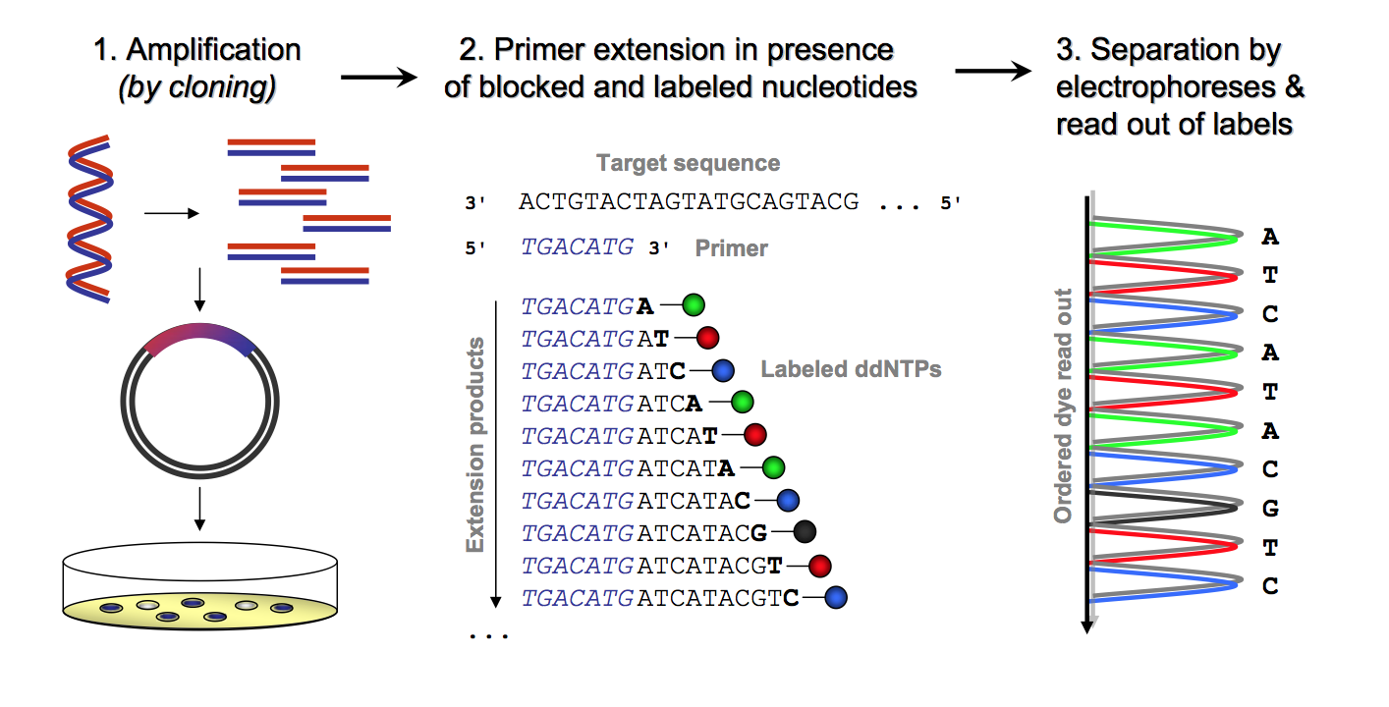

Figure 9: The workflow in Sanger sequencing. This image comes from Kircher, M. (2011). [Understanding and improving high-throughput sequencing data production and analysis](http://www.qucosa.de/recherche/frontdoor/?tx_slubopus4frontend%5bid%5d=urn:nbn:de:bsz:15-qucosa-71102)

The key insight for understanding Sanger sequencing is to understand that it is *sequencing by synthesis*. In the core sequencing reaction (figure 10), DNA polymerase and de-oxy nucleoside triphosphates (dNTPs: the building blocks of DNA) are supplied, but with one crucial addition. A small proportion (~1/100th) of the dNTPs are modified. These modifications entail the loss of a 3’-OH group required to add the next base during DNA synthesis. These are referred to as di-deoxy nucleoside triphosphates (ddNTPs) or chain terminators.

In addition to stopping DNA synthesis these ddNTPs also carry a fluorescent dye, with a different dye used for each ddNTP: for ddATP, ddCTP, ddGTP and ddTTP. Because there are many copies of the DNA after cloning there will be a large population of fragments after synthesis. These will terminate whenever a ddNTP has been incorporated. Some will be short because they incorporated a chain terminator early by chance, others will be long because it took longer before the chain terminator was incorporated. However, if there is, for example, a G (guanine) at position 100 in the original sequence, any newly synthesised DNA that is exactly 100 bases in length will always be terminated by a ddGTP and labelled with the corresponding fluorescent dye.

In the third and final step of Sanger sequencing (figure 9), DNA is separated by length at a single base resolution and a graph (called a chromatograph) is generated showing the fluorescent response of fragments of each length. Figure 10 shows the present method by which this is achieved, which is by passing DNA through a capillary. Prior to the development of capillary methods DNA was often separated on gels and radioactive methods were used to detect ddNTPs. Because a radioisotope cannot be used to distinguish bases – it can only indicate that a base has been incorporated at the end – this means that the original “black-and-white” Sanger sequencing entailed four separate reactions, one for each base. If you’ve ever seen an old movie or a science documentary in which lab-coated professionals are pondering gel images, you may have seen this older instantiation of Sanger sequencing.

Modern Sanger sequencing methods can achieve a read length of ~800-1000 bases. One reason for the limited size of reads is that it is harder to separate two synthesised fragments of length 1000 and 1001 than it is to separate two fragments of length 10 and 11. However, as we will see, 1000 bases is actually quite long! Sanger sequencing was the technology used for the human genome project and, since the human genome is very large, you can imagine that it took a long time, and a lot of money, to sequence and piece together the genome.

One trick that helped was the use of large vectors such as yeast artificial chromosomes (YACs) so that large regions of a human chromosome could be processed at a time. From ~2005 new technologies started to emerge that significantly reduced the cost of sequencing and these technologies will be discussed next. However, Sanger sequencing itself has seen improvements with time and the current technologies allow for substantial parallelisation of the process with the brand “Applied Biosystems” (AB) generally leading the market.

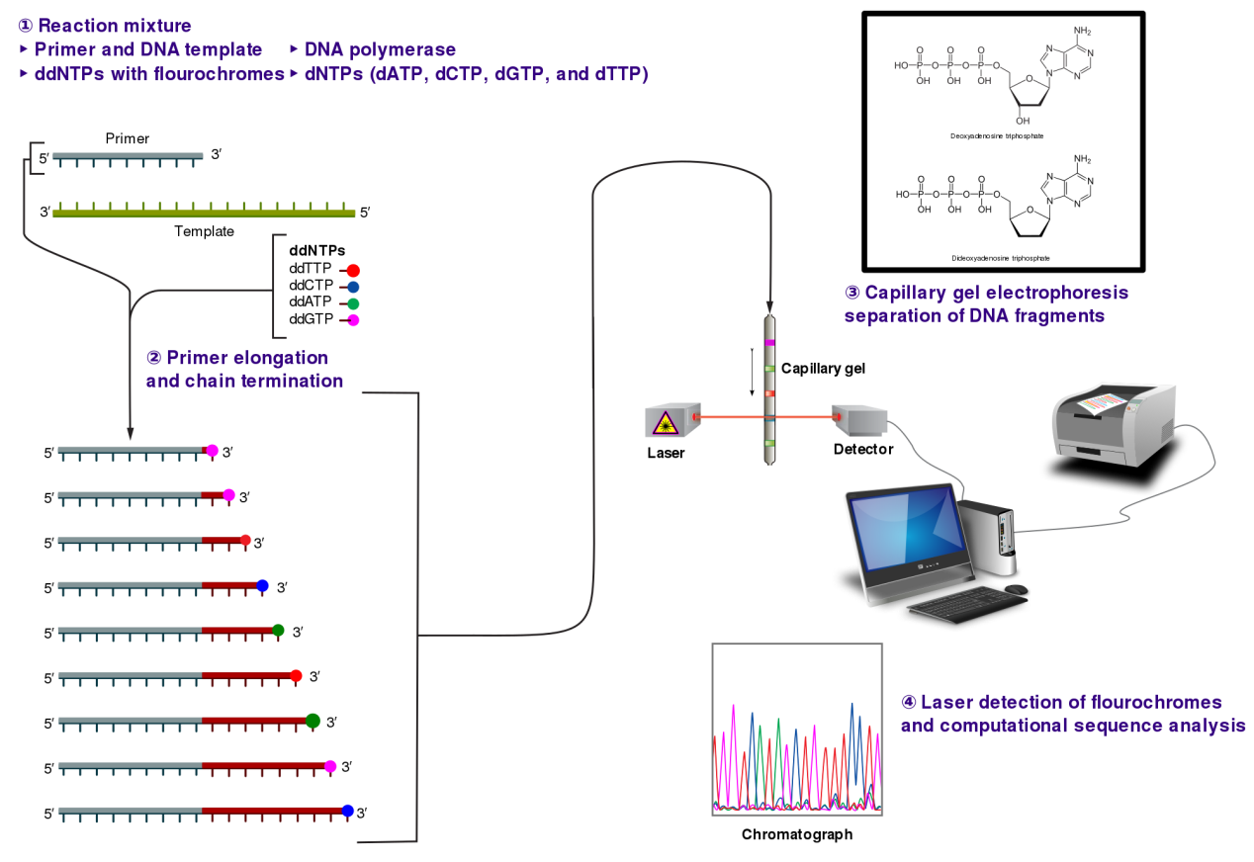

Figure 10: Primer extension and fragment detection in Sanger sequencing. Image from: <https://upload.wikimedia.org/wikipedia/commons/thumb/b/b2/Sanger-sequencing.svg/2000px-Sanger-sequencing.svg.png>

* + 1. **Massively Parallel Sequencing Technologies**

In 2005, Margulies et al. sequenced almost the entire genome of a bacterium called *Mycoplasma genitalium* in a single sequencing run. The genome of this bacterium is quite small (~580kb), but in order to sequence it before this date a “total of 9846 sequencing reactions were performed by five individuals using an average of eight AB 373 DNA sequencers per day for a total of 8 weeks” (Fraser et al., 1995).

So, what was the nature of the technology that allowed such a breakthrough? The key principle you know already = massively parallel sequencing and we will get to the details of this in a moment, but let’s start with the basic sequencing chemistry at work here. The sequencing method used here was, like Sanger sequencing, based on sequencing by synthesis, but on this occasion without fluorescence or chain termination. The method is called pyrosequencing.

* + 1. **Chemistry of Pyrosequencing**

In pyrosequencing, a strand of DNA to be sequenced (with a primer bound to one pad sequence) is supplied with DNA polymerase and dNTPs, but in addition the enzymes ATP sulfurylase, luciferase and apyrase are supplied along with the substrates adenosine 5’ phosphosulfate (APS) and luciferin. In the first step of the reaction (figure 11), a complementary dNTP is incorporated into the new strand. Remember that dNTP stands for a de-oxynucleoside triphosphate.

If you know the structure of DNA you may be aware that the DNA backbone consists of a sugar (deoxyribose) alternating with a single phosphate group. This means that two of the phosphates are kicked out when a dNTP is incorporated yielding a pyrophosphate group (PPi). In the second step the enzyme sulfurylase is able to convert PPi into ATP (adenosine triphosphate) using APS (supplied, see above). ATP is a vital carrier of energy in metabolism and can be used to power all sorts of reactions. In step 3, it is used by the enzyme luciferase to oxidise luciferin, a reaction each instance of which results in the release of a photon. It is this photon that can be used to detect the incorporation event. Finally, the enzyme apyrase can be used to recycle unused nucleotides and ATP.

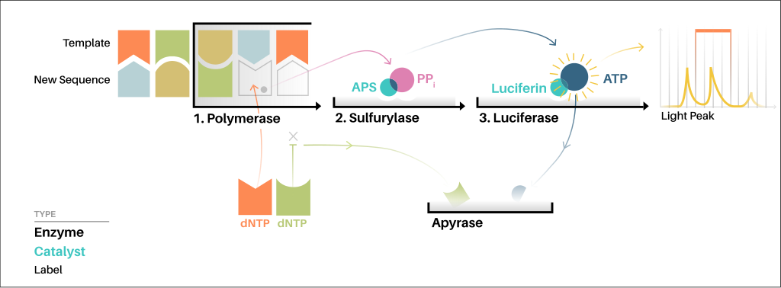

Figure 11: The process of pyrosequencing by synthesis. Image from: <https://upload.wikimedia.org/wikipedia/commons/a/a2/How_Pyrosequencing_Works.svg>

This image has been created during "DensityDesign Integrated Course Final Synthesis Studio" at Polytechnic University of Milan, organized by DensityDesign Research Lab in 2015. Image is released under CC-BY-SA licence. Attribution goes to "Jacopo Pompilii, DensityDesign Research Lab". (Own work) [CC BY-SA 4.0 (https://creativecommons.org/licenses/by-sa/4.0)], via Wikimedia Commons

*Refinements*

I did simplify a little bit in the last paragraph to get the point across. First, pyrosequencing is a black-and-white technology (like the original Sanger sequencing). The light flash is the same colour whatever base is incorporated so it is necessary to carry out the reaction with each separate dNTP (e.g., just with dCTP, or just with dGTP, etc.) one at a time. Fortunately, the development of the apyrase step allows for reactions to be carried out sequentially, which increases efficiency. Second, and related to this, it is possible for more than one dNTP to be incorporated in a single step if the same base is repeated (two or more bases in a sequence that are the same is called a *homopolymer run, e.g., AAA*). Homopolymer runs can be resolved by examining the strength of the signal during each reaction with a stronger-than-baseline signal accruing if >1 dNTPs per molecule are incorporated. Third, the chemists among you may be concerned that ATP (the substrate for luciferase) and dATP are quite similar to each other and the latter might lead to light production in the absence of dATP incorporation. In fact, instead of dATP a variant called dATPαS is supplied instead, which is not capable of triggering luciferase.

* + 1. **454 Sequencing**

That’s the chemistry of pyrosequencing, but how can it be made (massively) parallel? Parallelisation was achieved by Marguiles et al. (2005) by means of what is called “polony” (or polymerase colony) sequencing. The idea here is to generate numerous separate reactions at the same time (for further details and antecedents [this Wikipedia article](https://en.wikipedia.org/wiki/Polony_sequencing) is quite detailed). Polony arrays for 454 sequencing are generated in two steps.

The first step is called emulsion PCR. DNA fragments to be sequenced are mixed with capture beads at a limiting dilution so that most of the sepharose beads capture either 0 or 1 individual DNA fragments. When oil and the ingredients for PCR are added to this mix an emulsion is generated. The drops within the emulsion capture beads and act as micro-reactors within which each PCR reaction proceeds. At the end of emulsion PCR, each bead carries multiple (clonal) copies of the original PCR fragment. The second step, involves loading the beads onto a microfabricated microarray called a PicoTiterTM plate. The wells in this plate are 44μm across and only a single bead or no bead should be present in each well. Next, the required enzymes and substrates are supplied to the plate and each dNTP is washed sequentially across the plate. Within each well that contains a bead the pyrosequencing reaction proceeds and generates light pulses that can be detected by an CCD camera system.

*Refinements*

An overview of this process is shown in figure 12 and again there are a few refinements. In order for capture to work properly the fragments to be sequenced must have a different adapter attached to each end. One of these adapters is attached to biotin and streptavidin beads are used to filter out fragments with incorrect adapter compositions. DNA flanked by the A and B adapters is denatured from these beads and then added to the capture beads (step 1 above). Capture beads have short oligonucleotides attached, which are complementary to one of the adapter sequences.

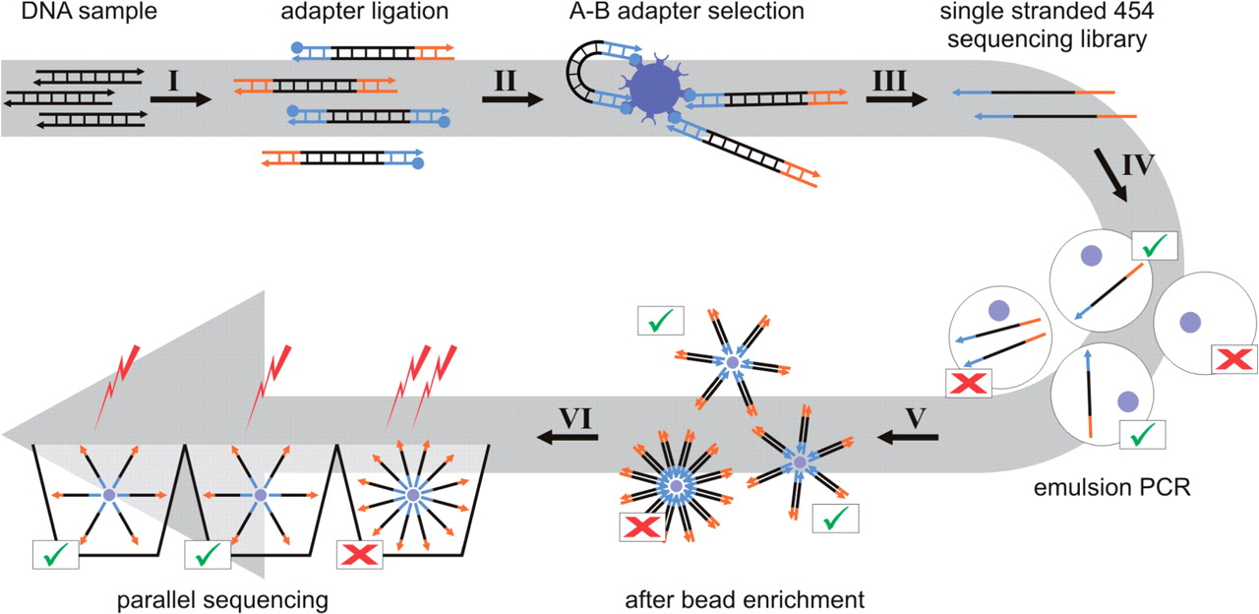

Figure 12: The full workflow for 454 sequencing. A and B adaptors are indicated in orange and blue, respectively, with the biotin indicated by a blue ball and streptavidin as a purple receptor. Sepharose beads are indicated as purple circles. Figure from Meyer et al. (2007).

The technology known as 454 sequencing is built from these components and enables the sequencing hundreds of millions of bases in a day with a relatively long read length of ~700 bases. Unfortunately, 454 technology (originally produced by 454 Life Sciences before being taken over by Roche Diagnostics) is now discontinued, but this is the technology that launched the next-generation revolution in sequencing.

In section 3.5 we will explore how a jigsaw puzzle of numerous separate reads derived from sequence fragments themselves derived from fragmentation of a genome can be reassembled to re-construct the original sequence.

* + 1. **Illumina Sequencing**

Illumina sequencing is probably, at the time of writing, the most popular next-generation sequencing technology. It was introduced in 2007 as Solexa sequencing (the name changing as a result of corporate activity). The approach is also based on sequencing by synthesis and, like Sanger sequencing, it uses fluorophores to identify bases. The key difference from Sanger sequencing, however lies in its use of reversible terminators.

*Chemistry*

In Sanger sequencing with fluorophores a template C (cytosine; for example) can either be matched by dGTP, in which case the strand continues to extend or by a labelled ddGTP, in which case the chain terminates and is fluorescently active. As the reaction proceeds fewer and fewer templates are available. In Illumina sequencing, bases are incorporated as 3’-O-azidomethyl 2’-deoxynucleoside triphosphates (A, C, G or T) labelled with different fluorophores (so they are all added at once). ***Every time*** one of these is incorporated it brings about chain termination. If this were all that happened then the reaction would never proceed past the first base incorporation. However, after detection (by excitation) of the fluorophore, tris(2-carboxyethyl)phosphine (TCEP) is added (Bentley et al., 2008). TCEP cuts off the 3’ modification of the last incorporated nucleotide (including the fluorophore). At this point the next incorporation reaction can begin.

In principle, this reaction can continue indefinitely with the number of reaction cycles corresponding to the length of sequence reads. However, occasional failure to incorporate on a given DNA strand in a cluster of identical strands results in “phasing” errors. These and other errors associated with fluorescence detection affect the realizable length of reads. While early experiments achieved read lengths of 26 nucleotides, it is now common to achieve lengths of 250-300 nucleotides (depending on the exact chemistry used).

*Parallelisation*

For 454 sequencing, we learnt that beads were used to prepare clonal DNA for lots of DNA samples in parallel (via emulsion PCR) before addition to an array. In Illumina sequencing, parallelisation is achieved *in situ* on the sequencing substrate, which is known as a flow cell. Single-stranded DNA fragments to be cloned/amplified are added to the flow cell which is coated with short oligonucleotides complementary to the sequence at one end of the fragments. Fragments are captured by oligonucleotides through base pairing. Synthesis of a new strand initiates from the double-stranded region at the base of the flow cell so that the new strand is now covalently attached to the flow cell. The original fragment of DNA can now be removed by denaturation.

The next-step is a little complex. It turns out that there are two types of oligonucleotide attached to the flow cell and the other type of oligonucleotide is complementary to the other strand of the DNA sequences. Our new covalently attached DNA strands will occasionally bow down and when they do so they can become attached to these a complementary oligonucleotide creating a bridge-like structure. Now, another strand of DNA can be synthesised from the new paired region. This process is called bridge amplification. After repeated round of denaturation and bridge amplification, clusters of identical sequences are produced. At this point a modification within one of the two types of oligonucleotide on the flow cell is used to sever the fragments at one end and ensure that all members of the cluster are oriented identically.



Figure 13: An overview of Illumina sequencing including parallelisation procedures and the sequencing reaction. Image Credit: <http://www.3402bioinformaticsgroup.com/service/>

*Refinements*

The processes described above begin with DNA fragments with known sequence ends. How are these ends attached? For standard Illumina sequencing this is achieved by ligation of Y-shaped adapters to DNA fragments. DNA fragments may be prepared in several ways, but, after repairing the ends, an A (adenosine) is added to the 3’ ends. The Y-shaped or “forked” adapters are non-complementary at one end but complementary at the other end, where they attach to the DNA fragment. At the complementary end, the strand with the 3’ end has an overhang of one base, which is a T (thymidine) and is attached via a phosphorothioate bond (making the T difficult for exonucleases to remove). The complementary strand is in the opposite orientation (because DNA strands are anti-parallel) and carries a 5’ phosphate to promote DNA attachment.

Although identical forked adapters bind to each end of a DNA fragment a single primer complementary to only one of the two sequences (exploiting the non-complementary region) is used to amplify DNA fragments with unique ends. A second primer may then be used to amplify the complementary strand. After a few rounds of amplification a “library” of DNA fragments may be denatured (made single-stranded) using sodium hydroxide reading for loading (at low concentration) onto the flow cell. More details about the primer sequences used may be [found here](http://bioinformatics.cvr.ac.uk/blog/illumina-adapter-and-primer-sequences/) (and if you are really interested you may be interested in the [alternative approach](https://www.neb.com/-/media/catalog/Long%20Description/E7600DNA_Illum_LoopAdaptor_workflow.png) offered by New England Biolabs).

Most modern Illumina sequencing exploits additional modifications to allow sequencing of both ends of the fragments. This is called paired-end sequencing. After sequencing via synthesis of a new strand on each molecule in a cluster, the new strands are chemically denatured and removed. After extra bridge amplification steps, the molecules can again be severed at one end, this time by targeting a chemical modification in the other type of oligonucleotide on the flow cell.

For a video overview of the Illumina sequencing methodology you can see [this website](https://www.illumina.com/science/technology/next-generation-sequencing/sequencing-technology.html).

* + 1. **SMRT Sequencing (Pacific Biosciences)**

The sequencing technologies described so far have relied upon the preparation of multiple identical strands of DNA, either through cloning or PCR (for Sanger sequencing), via bridge amplification (for Illumina sequencing) or via emulsion PCR (for 454 sequencing). In addition to this process some prior amplification of DNA is common in library preparation procedures for these technologies. All this replication introduces the possibility of error. Every time a DNA strand is replicated (by a polymerase enzyme) mutations can arise resulting in inconsistent or incorrect base calls during sequencing.

Another feature common to the technologies about is that the sequencing reads (the data obtained from a cluster of identical sequences) are limited in length owing to the fragmented nature of the input DNA and the degradation of signal quality during the sequencing reaction.

A radical departure from these technologies is the use of single-molecule sequencing. In principle sequencing a single-strand of DNA would allow one to avoid both of these problems. However, we then encounter a really difficult engineering problem: the weakness and transience of any signal (e.g., a single photon) obtained from the incorporation of a single nucleotide. This is, in fact, why we work with clonal copies in other technologies: to increase the signal-to-noise ratio for each sequencing reaction.

Single-Molecule Real-Time (SMRT) sequencing solves this problem in a really intriguing way. In the technology developed by Pacific Biosciences (often abbreviated PacBio), a complex of a DNA molecule and a DNA polymerase enzyme are immobilised at the base of an exceptionally small chamber called a zero-mode waveguide (ZMW). The ZMWs are illuminated from below and their dimensions are so small that light is only able to penetrate into the very bottom of each ZMW (in a volume measures in zeptolitres, that’s ~10-21L!). This cone of light provides the excitation required for fluorescence, as well as hugely reducing the background noise so that single events can be detected (figure 14).

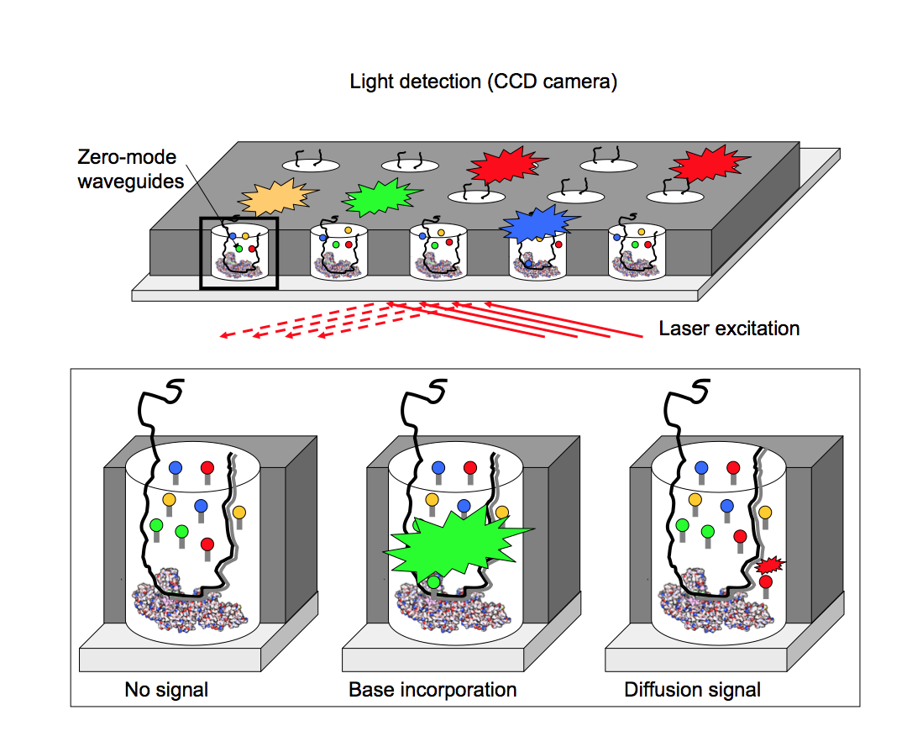

Figure 14: An overview of signal detection in PacBio sequencing. This image comes from Kircher, M. (2011). [Understanding and improving high-throughput sequencing data production and analysis](http://www.qucosa.de/recherche/frontdoor/?tx_slubopus4frontend%5bid%5d=urn:nbn:de:bsz:15-qucosa-71102)

As in Illumina or Sanger sequencing the nucleotides that are incorporated carry the fluorophores required for fluorescence, however there is no termination chemistry and the reaction proceeds at speed and therefore requires monitoring in real time. If you’re still not getting a sense of it, [here is a silent video](https://youtu.be/WMZmG00uhwU) from Pacific Biosiences showing an overview of the sequencing process ([another video](https://youtu.be/WMZmG00uhwU)).

Despite this clever approach the per-base error rate of this technology remains higher than previously discussed technologies. However, when multiple reads can be obtained from the same DNA source (e.g., genomic material prepared from a tissue sample), it is possible to increase the accuracy by aligning reads together. The final “consensus” accuracy can be much higher.

* + 1. **Nanopore Sequencing (Oxford Nanopore)**

Another approach to single-molecule sequencing is to extrude a DNA molecule through a small hole in a membrane! In Nanopore sequencing these small holes can be in the form of transmembrane proteins called porins (=biological) or they can be minute holes in a metallic material (solid state). The company currently dominating this field is Oxford Nanopore (based in the UK) and they develop biological Nanopore platforms.

To understand how a DNA passing through a pore can be used to obtain sequence information, you should first know that a potential difference (voltage) is applied across the membrane in which the pores are embedded. If a pore is open some current will therefore flow through the pore. The exact amount of current flowing will depend on the pore’s state at each moment in time. If a molecule travels through the pore it will distort and block the pore in various ways that depend on the molecule’s size and shape. The effects of this transition through a pore on the current can be detected in the current signal. Each nucleobase in DNA has a different characteristic shape and therefore the four DNA bases (A, C, G and T, as well as many base modifications found in some genomes) can be detected in the current signal. Again, this happens at speed and signal processing requires sophisticated algorithms (including machine learning approaches).

For an overview of the basic technology take a look at the [video on this page](https://nanoporetech.com/resource-centre/videos/introduction-nanopore-sensing). Oxford Nanopore have developed a range of devices using this technology including a device that is small enough to connect to a mobile phone! This is a highly active area of development at the time of writing.

So, there we have it. We have discussed some of the main massively parallel sequencing technologies. There have been and are others (for a wider review [see this paper](https://www.ncbi.nlm.nih.gov/pmc/articles/PMC3437308/)), but the technologies discussed here show the range available and the most important technologies over the last decade or so.

* 1. **Sequencing Analysis**
     1. **Sequencing Use Cases**

Sequencing has a variety of use cases beyond the obvious one of sequencing a new genome. First, sequencing can be used to sequence a novel genome. Sequencing a genome from scratch is often referred to as *de novo* sequencing. This may be distinguished from re-sequencing, that is sequencing an individual organism when a genome sequence is already available for that organism.

Why might we wish to re-sequence an organism? For an example, you might wish to sequence your own genome even though the reference genome is already available. The answer is that you may wish to know about variation within a species. In our example, you may wish to know how your genome differs from the hg38 reference.

As well as sequencing genomes we can sequence other (discontinuous) compartments of the genome:

* the exome (all exons),
* the transcriptome (all transcripts),
* the epigenome (all epigenetically modified regions).

At one point everyone’s “favourite-ome” became a bit of a logorrheic competition, so you may find some other -omes out there in the literature, but these are the key ones for looking at parts of the genome. In particular, transcriptomics entails converting total RNA or mRNA into cDNA prior to sequencing and provides an excellent way to examine global gene expression. Epigenomic methods include methods to detect DNA methylation (typically of cytosine residues in CpG dinucleotides) or of DNA closely associated with modified chromatin (in a procedure called chromatin immunoprecipitation sequencing or ChiP-seq).

We can also sequence DNA from a mixed source. This is often referred to as metagenomics (with “meta” doing the usual linguistic trick of referring to an abstraction). This entails taking a sample from the environment (e.g., some soil), extracting and purifying DNA from it and sequencing it. In this instance we expect the presence of genomic material from the genomes of multiple species (even different domains of life). By comparing sequences obtained in this way with databases we can infer the diversity and abundance of different forms. Often it is not possible to confidently assign all DNA to a single species, especially since a large number of species are unknown, so we refer instead to Operational Taxonomic Units (OTUs). We can also observe the range of genes present in the environment even when we are not sure which organisms they belong to. As odd as this seems, this can be an immensely powerful tool for the ecologist.

For completeness, a more focused metagenomics method can be used in which DNA from the genes encoding ribosomal RNA (rRNA, in particular the small subunit) can be amplified and sequenced. This region is conserved across all non-viral organisms and changes only very slowly over evolutionary time. Therefore, sequences can be used to assess phylogenetic diversity.

Finally, it is possible to sequence DNA from a population of organisms of the same species. Very small differences between sequences can be used to detect diversity within a population. This is technically challenging and is referred to as deep sequencing.

* + 1. **The Two Main Problems**

To analyse the types of sequencing data described in the previous section two different types of problem may need to be solved.

The easier of these is called alignment (or sometimes “mapping”). Here sequence reads must be aligned (or mapped) against the known reference genome. In theory you can imagine simply moving each read along the genome until it looks the same (or very similar) and then doing that with each and every read (these are measured in the tens of millions). However, as we discuss in section 3.5.3, it is a little more complex than this.

The harder problem is called assembly. Here the sequence reads must be put together, finding areas of overlap between them until we can reconstruct long tracts of DNA corresponding to a chromosome or region of the genome. Contiguous tracts of sequence are called “contigs”. Assembly is therefore about constructing plausible contigs from sequence reads (section 3.5.4).

* + 1. **Alignment Algorithms**

As indicated in the previous section alignment is a little more difficult than it seems. Figure 15 shows the outcome we are looking for: the alignment of reads against a reference. Look closely, however and you can see one of the problems. Sometimes a sequence may differ from another owing to an insertion in one (or equivalently a deletion in the other). This is represented in figure 15 by the * character indicating a gap introduced to align a portion of a sequence read to the reference. Doing this correctly requires an awareness of the possibility of errors in the sequence data and in the alignment process.

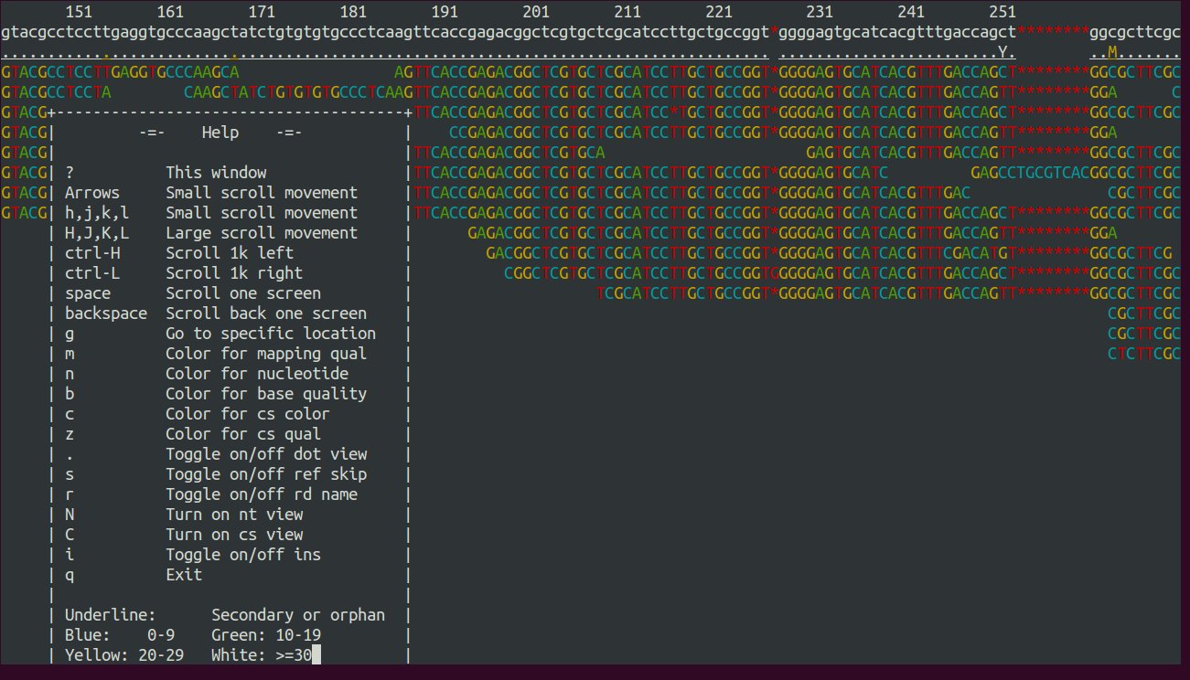

Figure 15: An example of aligned sequence reads, against a reference genome. The program used to display these is called tview (part of the SAMtools toolkit). Image reference: <http://marinetics.org/teaching/hts/MappingVariantCalling.html>

Another problem is that the reference genome can be very large, so that it would take an inordinate amount of time to align each read against our genome. As described in section 3.3 with the BLAST algorithm, one solution to this is heuristic search. One structure used to achieve this is a “hash table”. This is a memory structure in which either the reference genome or the sequence reads are “indexed” to note the location of all seeds. Remember that seeds are just very short sequence used to start a sequence alignment. We require that they match exactly.

So, imagine that a reference genome is indexed in a “hash table”. This would look something like a dictionary with each entry being a seed and the detail in the entry giving the location in the reference of all copies of that sequence. The next step in the alignment process would be to identify seeds in your sequence read and simply look them up in the dictionary/hash table. Finally, as with BLAST, more detailed algorithms can be used to check the quality of a putative alignment.

This process is very efficient, but early on the sheer number of sequence reads made the memory requirements of this search prohibitive. A solution was identified in the form of an algorithm called the Burrows-Wheeler transform. This is a little similar to the algorithms used to zip files on your computer. Figure 16 shows the basic process of rearranging the letters in a sequence using the Burrows-Wheeler transform.

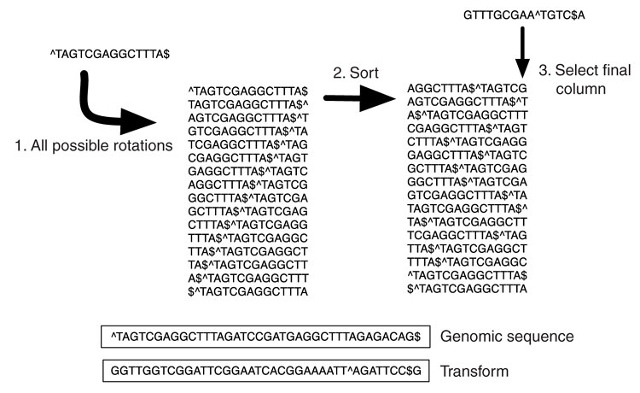

Figure 16: An example of the Burrows-Wheeler Transform applied to a DNA sequence. Note that the ^ character denotes the start of the line and the $ character denotes the end. Image from Flicek and Birney (2009).

This might appear to be pointless, but the transformed sequence has some useful properties:

1. It can be transformed back again with no additional information
2. It tends to comprise more repeated letters than the original

Property 1 means that we can work with the transformed sequence rather than the original because they are equivalent. Property 2 means that we can represent the sequence using less memory. Think of the number of characters in this line:

AAAAAA

Versus this one:

6A

Many programs are available to carry out sequence alignment with exotic names such as:

* Lastz (dynamic programming)
* ELAND (Illumina; index reads with hash table)
* MAQ (index reads with hash table)
* NovoAlign (index genome with hash table)
* BarraCUDA (GPU-accelerated version of BWA)
* **Bowtie 2 (BWT)**
* **BWA (BWT)**

The last two highlighted in red are currently very popular for standard genome sequencing. Using these programs requires use of the UNIX command line environment. For completeness, it is also worth noting that alignment can also be used in the context of transcriptomics where some other amusingly named programs can be used:

* FANSe (RNA-seq)
* **TopHat (RNA-seq)**
* **Cufflinks (RNA-seq)**

The last two highlighted are part of the Tuxedo suite of programs, also run via the UNIX command line.

* + 1. **Assembly Algorithms**

Assembly is the process of finding overlaps between sequence reads and using these to construct contigs (contiguous regions of sequence). Two sequences may overlap owing to chance similarity or because they cover overlapping regions of the genome:

AAGACTACAGCTA

|||

CTAACAGCACAGCAT

Contigs must therefore be inferred from the data with care to avoid inaccurately assembling a genome. This task becomes particularly difficult when you consider that some parts of the genome are quite similar to others, even when they are very distant from them. (One cause of this is transposons which make up large portions of eukaryotic genomes including our own.)

This problem would appear to be simple – you can just line up all the reads against each other, pairwise. But look at that again and you will realise that if you double the number of sequences you are more than doubling the number of comparisons required to complete your task. The solution turns out to be related to an intriguing problem in mathematics called finding the Eulerian cycle (named after the 18th centry mathematician Leonhard Euler). This is very nicely described (with figures) by Compeau et al. (2011). In brief when reads or parts of reads are represented as the “edges” in a graph (edges are the lines connecting the points), the method of finding nodes (that’s the points) that link the prefixes (front part) of some edge sequences with the suffixes (end part) of others is much more efficient than an exhaustive pairwise comparison. To keep the number of nodes (overlapping regions) small, the reads are broken into small parts called k-mers. A k-mer is just a sequence that is k bases in length. Suprisingly breaking our sequence reads down into smaller pieces makes assembling them much easier!

Here is a list of algorithms that have been developed to assemble genomes:

* EULER
* ALLPATHS
* SOAPdenovo
* Velvet
* **ABySS**
* **SPAdes**

Of these the last two are currently the most popular. A substantial advantage of SPAdes is that it chooses the length k, for those k-mers, for you. It does this based on a number of metrics related to the number and consistency of the contigs recovered. This saves a lot of thinking! Again for transcriptomics alternatives exist such as:

* Trinity (RNA-seq)

A key concept in transcriptomics is the idea of coverage which is indicating the number of reads supporting a given contig (in assembly) or the number of reads overlapping with a particular region in the reference (for alignment).

* + 1. **Assembly Quality**

The reliability of an assembly can be assessed by looking at the number of small contigs and also at the number of larger contigs. The difficulty is that both of these things are important for measuring the quality of an assembly. You don’t want lots of small pieces, but you could tolerate some small pieces if there are some very large ones present also. A measure that has been developed to account for this is called the N50.

The N50 is that number such that at least half the total length of contigs are contained in contigs of at least that length. That’s not easy to understand as a sentence! There’s an easier way to communicate it.

*Procedure*

Take your contigs and order them from the longest to the shortest. Here are the lengths of some toy contigs written down:

6 > 5 > 4 > 3 > 2 > 2

Add them all up to find the total length of contigs (presumed to be similar to the genome size):

6 + 5 + 4 + 3 + 2 + 2 = 22

Take half that number (50%):

22 / 2 = 11

Proceed through the contigs, adding them up as you go, until you get to 11:

6 = 6

6 + 5 = 11

OK! Stop there! We’ve already gone reached 11! And that was with a contig of length 5:

**6 > 5** > 4 > 3 > 2 > 2

So the N50 = 5.

*Interpretation*

Now the larger the N50 the more of the genome is concentrated in just a few large contigs and that’s the really important thing. In fact, you can also have NX where X is any percentage of the full length of contigs, e.g., N25 refers to that contig length such that 25% of the total length is contained within contigs of at least that size (one of those sentences again!). If you already know the genome size for some reason you can use that instead of the total contig length and then we have NGX (G for genome).

A common piece of software for calculating the N values from an assembly is QUAST. These sorts of metrics can even be used in competitions in which different assembly algorithms are compared. One of these competitions is called Assemblathon 2 (Bradnam et al., 2013)!

Finally, let me tell you about one last concept: a scaffold. A scaffold is made up of two or more contigs connected to each other by some unknown sequence. Sometimes (owing to paired end sequencing), you know that two sequences are close together, you even know how close they are, but you can’t quite connect them together in a contig. The N50 metric can also be applied to scaffolds as well as contigs.

* 1. **Conclusion**

In the preceding sections you’ve had a flavour of the variety of sequencing technologies and methods applied to interpret data from them. I hope this has been interesting and I look forward to discussing this with you.

* 1. **Bibiliography**

Bentley, D.R., Balasubramanian, S., Swerdlow, H.P., Smith, G.P., Milton, J., Brown, C.G., Hall, K.P., Evers, D.J., Barnes, C.L., Bignell, H.R. and Boutell, J.M., 2008. Accurate Whole Human Genome Sequencing using Reversible Terminator Chemistry. *Nature*, *456*(7218), p.53.

Bradnam KR, et al. (2013) [Assemblathon 2: evaluating de novo methods of genome assembly in three vertebrate species](http://dx.doi.org/10.1186/2047-217X-2-10)*. Gigascience*. 2(1):10

Compeau PE, Pevzner PA, Tesler G. (2011) How to apply de Bruijn graphs to genome assembly. *Nature Biotechnology.* 29(11): 987-91

Fiers, W., Contreras, R., Duerinck, F., Haegeman, G., Iserentant, D., Merregaert, J., Jou, W.M., Molemans, F., Raeymaekers, A., Van den Berghe, A. and Volckaert, G., 1976. Complete nucleotide sequence of bacteriophage MS2 RNA: primary and secondary structure of the replicase gene. *Nature*, *260*(5551), pp.500-507.

Knight, R.D., Freeland, S.J. and Landweber, L.F., 2001. Rewiring the keyboard: evolvability of the genetic code. *Nature reviews. Genetics*, *2*(1), p.49.

Koonin, E.V., 2005. Orthologs, paralogs, and evolutionary genomics. *Annu. Rev. Genet.*, *39*, pp.309-338.

Flicek, P., & Birney, E. (2009). Sense from sequence reads: methods for alignment and assembly. *Nature Methods*, 6: S6-S12.

Fraser, C.M., Gocayne, J.D., White, O., Adams, M.D., Clayton, R.A., Fleischmann, R.D., Bult, C.J., Kerlavage, A.R., Sutton, G., Kelley, J.M. and Fritchman, J.L., 1995. The minimal gene complement of *Mycoplasma genitalium*. *Science*, 270(5235), pp.397-403.

Gilbert, W. and Maxam, A., 1973. The nucleotide sequence of the lac operator. *Proceedings of the National Academy of Sciences*, *70*(12), pp.3581-3584.

Margulies, M., 2005. Genome sequencing in microfabricated high-density picolitre reactors (Corrigendum). *Nature* 437, pp. 376-380.

Meyer, M., Briggs, A.W., Maricic, T., Höber, B., Höffner, B., Krause, J., Weihmann, A., Pääbo, S. and Hofreiter, M., 2007. From micrograms to picograms: quantitative PCR reduces the material demands of high-throughput sequencing. *Nucleic acids research*, *36*(1), pp.e5-e5.

Sanger, F., Air, G.M., Barrell, B.G., Brown, N.L., Coulson, A.R., Fiddes, J.C., Hutchison, C.A., Slocombe, P.M. and Smith, M., 1977. Nucleotide sequence of bacteriophage φX174 DNA. *Nature*, *265*(5596), pp.687-695.

Sanger, F., Coulson, A.R., Friedmann, T., Air, G.M., Barrell, B.G., Brown, N.L., Fiddes, J.C., Hutchison, C.A., Slocombe, P.M. and Smith, M., 1978. The nucleotide sequence of bacteriophage φX174. *Journal of molecular biology*, *125*(2), pp.225-246.